Using the Iditarod Race as a Teaching Tool in Year 9 Mathematics
Website: Iditarod.com
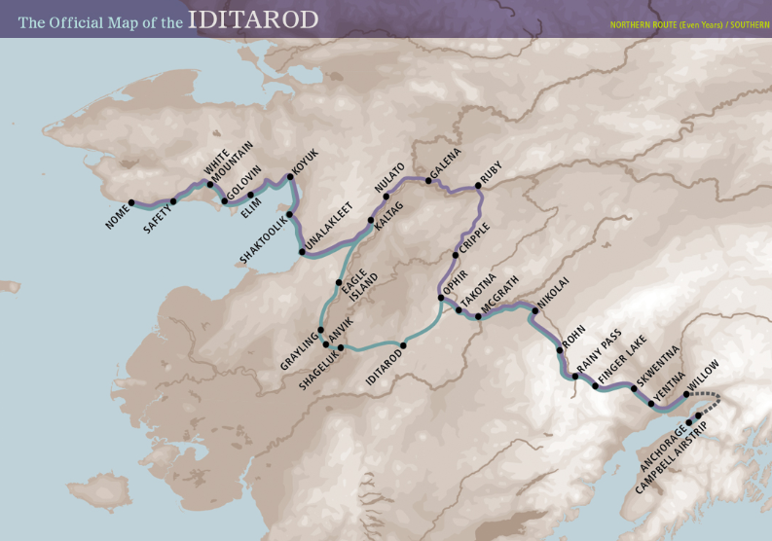
Activities from the iditarod.com website might include:
- Find the percentage of women and men signed up to run Iditarod 2013.
(How does this relate to real life? If you’re female and looking for a job, you can use this process to determine how many women the company you’re interested in hires. Or, you’ve got a construction job and you have to calculate the percentage of the job’s cost that the plumbing cost represents. It’s the same process as finding the percentage of men and women in Iditarod 2013!)
2. Use the complete musher listing information to create a bar graph representing the numbers of mushers from their various countries. Hint: open the list of mushers in the Iditarod website and copy and paste these into Excel-->delete unwanted columns (No., State, etc.), then select your list and --->right click--->sort, etc. When you have your sorted list you will need to make a summary table in Excel of the Country | No. entrants. Then go Insert--->Graph, etc.
(In real life, your job may require you to create a presentation with graphs and charts representing important information for your company or clients such as the counties or states in which your customers are located.)
3. Using the complete musher listing link, find the ages of the mushers by clicking on each musher’s name. For all the ages found, determine the average age of the mushers in Iditarod 2013. Then, create a stem-and-leaf plot which shows the number of mushers in age groups that you determine (18-23 years old, 24 -29 years old, etc.) showing gaps and clusters of their ages. Now create a frequency table showing how often their ages occur within age groups. Last, create a histogram to show ages using intervals. Stem-and-leaf plots order information and show a quantity of information in a small space. Frequency tables use tally marks to represent the times a number occurs in a group, and histograms look like bar graphs, but show information in intervals.
(Real life use? In real life, businesses create pictorial representations of their data to “see” the numbers.)

